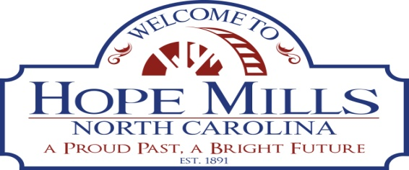

**FOR IMMEDIATE RELEASE** March 31, 2025

Contact:

Coronda Regan, Executive Assistant / Deputy Town Clerk

Telephone: 910-426-4112

**Goodwill Industries of Eastern North Carolina, Inc. Generously Donates $1,600 in Food Vouchers to Support the Town of Hope Mills Dignity Closet: Toiletry Chest Initiative**

HOPE MILLS NC — The Town of Hope Mills is thrilled to announce a generous donation from Goodwill Industries of Eastern North Carolina, Inc. (GIENC®) totaling $1,600.00 in Food Lion vouchers. This donation was meant to support the ongoing efforts of Hope Mills to continuously help those in need within the Cumberland County area. The partnership exemplifies the spirit of community collaboration.

The Hope Mills initiative, the Dignity Closet, presented the Toiletry Chest over the weekend on March 29, 2025. This project has become a cornerstone of our community's support network, and endeavors to provide resources of all kinds to individuals and families that need them. Through the dedication of volunteers and the support of organizations like GIENC, we strive to ensure that the members of our community feel supported.

“We are always grateful for the partnership with GIENC and their generous donation," said Chancer F. McLaughlin, Town Manager for the Town of Hope Mills. "Their contributions continue to enable us to expand our efforts. This partnership with Goodwill and their longstanding commitment to supporting communities in need will significantly bolster our future endeavors.

The donation of $1,600.00 in Food Lion food vouchers is a part of the GIENC Feeds Program and has helped to provide individuals and families with additional resources that they may need. Hope Mills and Goodwill Industries of Eastern North Carolina continue to work together to create a more vibrant community.

**About Goodwill Industries of Eastern North Carolina** - Goodwill Industries of Eastern North Carolina, Inc. (GIENC®) transforms lives through opportunities. For over 60 years, GIENC has empowered individuals, families and communities through employment, education, and life enrichment opportunities. A leader in innovative solutions, GIENC operates 43 employment program centers across the Greater Triangle, Sandhills and eastern North Carolina. Since 2022, GIENC has distributed over $500K in food vouchers and provided 5000 food boxes to combat food insecurity, awarded $4 million in grants to local tax exempts and worked extensively to bring STEAM related learning opportunities to youth in underserved communities. To donate or learn more about GIENC, visit [**www.gienc.org**](http://www.gienc.org)**.**